DevOps Project 1

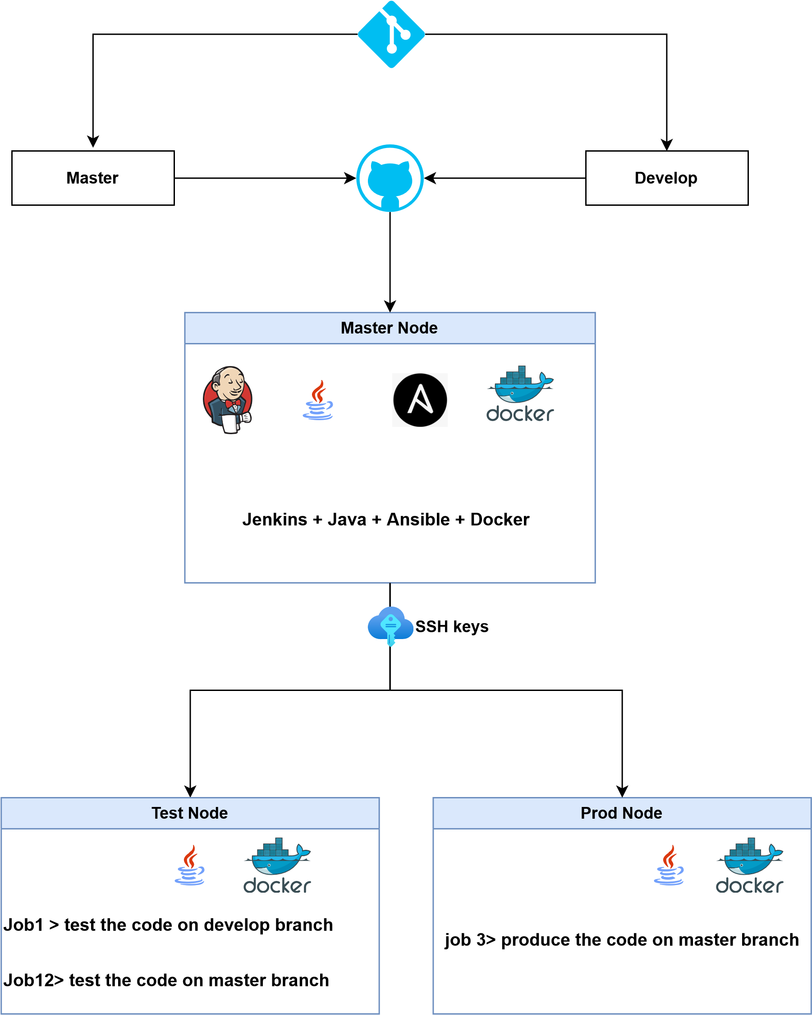

Project 1: Creating CI/CD pipeline

* **Implemented a GIT Workflow architecture using Jenkins jobs**
* **Deployed a container on specific ports for different branches**
* **Including the Develop branch for testing the Docker file and the Master branch for testing the final version of the Docker file**
* **Production Server for the final release of the product**

The above process was automated using Jenkins, GIT, Ansible, and Docker